EY
DUPONT Analytics Report
PowerBI assignment
Ruyi Zhong
14/05/2026

Contents
Introduction 2
Task 1 — Understanding Risks and Internal Controls 2
Task 4 — SQL Query Analysis 3
Task 5 — Internal Control Testing 3
Recommendations 6
Conclusion 6

Part 1: Ask the right questions
  - 1. Desired Direction for Each Ratio
Ratio | Preferred Value | Reason
Return on Equity (ROE) | High | Indicates the company generates strong returns for shareholders.
Profit Margin Ratio | High | Shows the company retains more profit from each dollar of sales.
Asset Turnover Ratio | High | Reflects efficient use of assets to generate revenue.
Financial Leverage Ratio | Moderate | Some leverage can improve returns, but excessive leverage increases financial risk.

  - 2. How Companies Can Improve Each Ratio
ROE can improve by Increasing net income or Reducing shareholders’ equity. Net income can be increased through higher sales, cost reductions, operational efficiency, or expansion into more profitable markets. On the other hand, shareholders’ equity can be reduced through share repurchases or by relying more on debt financing instead of issuing new equity. Although both approaches can mathematically improve ROE, in my opinion, it is better to focus on improving the numerator because stronger profitability reflects healthier and more sustainable business performance. Reducing equity too aggressively may artificially inflate ROE while increasing financial risk.
Profit margin improves when net income increases faster than revenue, costs are reduced or operational efficiency improves. Net income may improve through reducing production costs, improving operational efficiency, automating processes, negotiating better supplier contracts, or focusing on higher-margin products and services. Technically, the ratio can also improve if sales decrease less than profits decrease, but lowering sales is generally not considered a healthy strategy. Therefore, it is much better for a company to focus on improving the numerator, net income, because this reflects stronger profitability and operational performance rather than simply manipulating sales levels.
Asset turnover improves by increasing sales (the numerator) or by reducing total assets (the denominator). Sales can be increased through stronger marketing, expanding customer demand, improving distribution channels, or increasing customer retention. Total assets can be reduced by selling underutilized equipment, reducing inventory levels, outsourcing certain operations, or improving asset efficiency. In practice, the strongest improvement usually comes from balancing both approaches: generating more revenue while maintaining efficient asset usage. However, focusing on increasing sales is often preferable because excessive reductions in assets could limit future growth capacity or operational flexibility.

Financial leverage increases when assets grow through debt financing or equity decreases. Companies often increase assets by using debt financing to invest in expansion, new facilities, or additional operations. Equity can also decrease through share repurchases or large dividend payments. While higher leverage can increase shareholder returns and improve ROE, it also increases financial risk because the company becomes more dependent on debt obligations. For this reason, it is generally better to focus on carefully increasing productive assets rather than aggressively reducing equity. Moderate leverage may support growth, but excessive leverage can make a company financially unstable during economic
  - 3. Expected Industry Performance Before Analysis
Ratio | Expected Highest | Expected Lowest | Reason
ROE | Technology | Public Utilities | Many technology companies generate strong profits while requiring relatively low physical assets and equity investments compared to traditional industries.
Profit Margin | Technology | Consumer Services | Ttechnology companies often benefit from strong intellectual property protection, premium pricing, and relatively low marginal production costs.
Asset Turnover | Consumer Services | Finance | Consumer services were expected to have strong asset turnover because of high sales volume.
Financial Leverage | Finance | Technology | Finance industries were expected to have high leverage because banking and financial institutions rely heavily on debt financing.

Part 2: Extract, Transform and Load
*Please find the overview in Appendix “EY Dupont PowerBI”, tab ‘Data accuracy test’.
- Combined Total Assets of All Companies for All Years
Dataset | Total Assets
Balance Sheet only | 58,835,115,847,200
Matching BS & IS observations | 58,828,572,447,200

*The small difference suggests a few observations exist in the balance sheet but not in the income statement.

- Number of Different Companies
Dataset | Companies
Balance Sheet | 176
Matching BS & IS | 174

3. Number of Companies in Each Industry
Industry | Companies
Capital Goods | 29
Consumer Services | 28
Finance | 29
Public Utilities | 29
Technology | 30
Transportation | 29

*The calculation based on after matching BS&IS data.

- Total Sales for Each Industry in 2013
Industry | Total Sales
Consumer Services | 946,589,800,000
Capital Goods | 873,265,248,300
Public Utilities | 715,035,500,000
Finance | 697,163,500,000
Technology | 636,068,447,700
Transportation | 250,095,100,200

*Total sales across all industries:4,118,217,596,000

- Company with Highest Sales Over Three Years
Company | Total Revenue
Wal-Mart Stores Inc. | 1,431,200,000,000
*Top 5 companies by total revenue:
- Wal-Mart Stores Inc.
- Toyota Motor Corp. ADR
- Apple Inc.
- General Motors Company
- Ford Motor Company

Part3: Apply appropriate data analytic techniques
Questions About Industries
*Please find the overview in Appendix “EY Dupont PowerBI”, tab ‘Industry analysis_1’, ‘Industry analysis_2’.
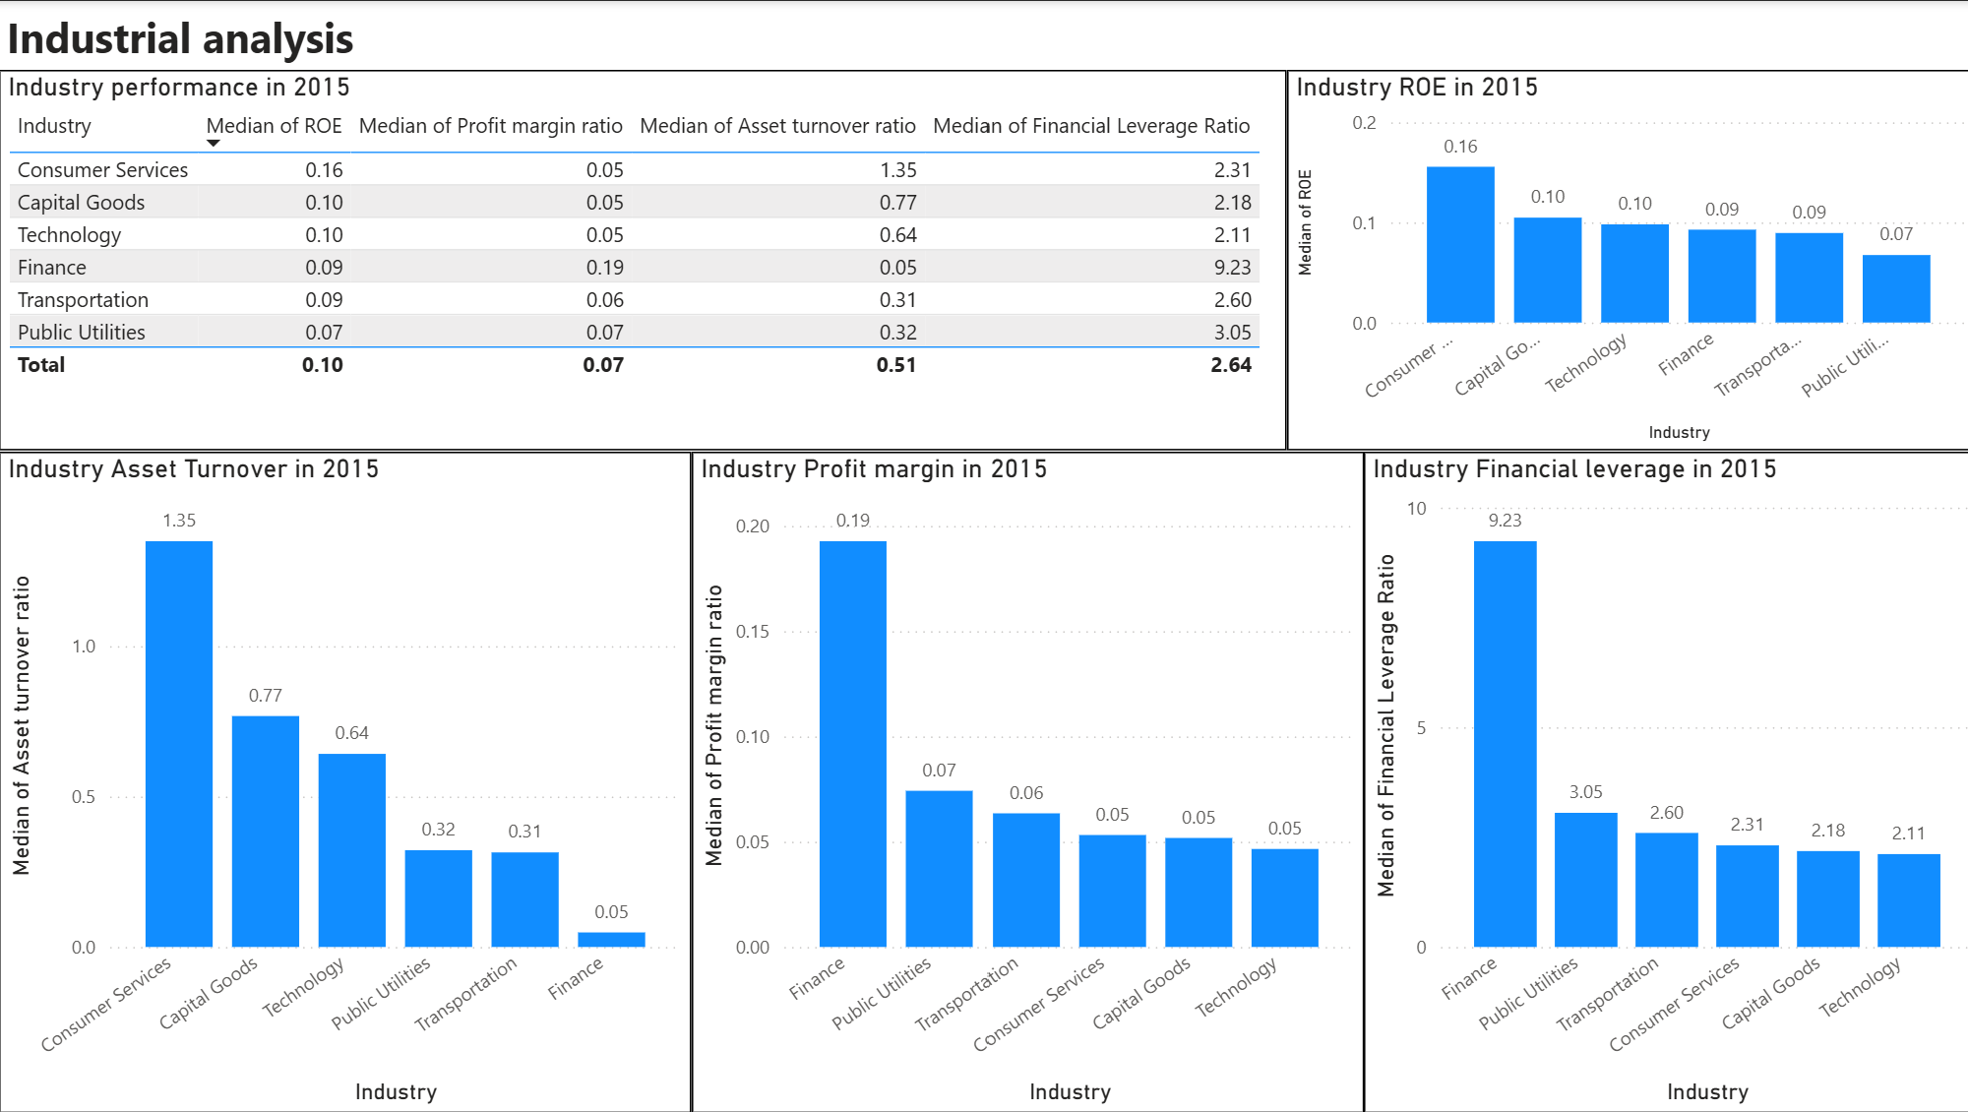
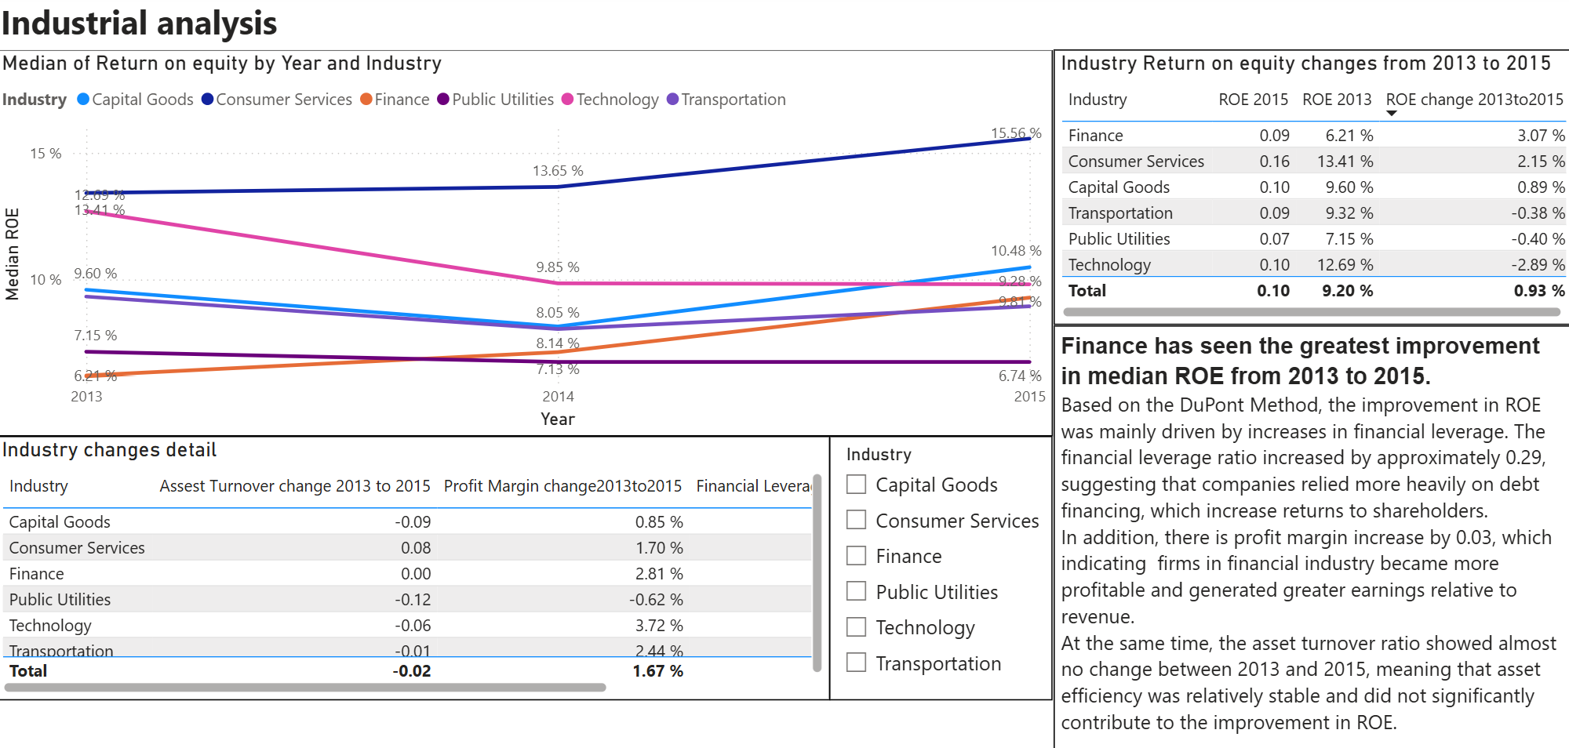
- Highest and Lowest Industry Performance in 2015
Median Industry Performance
Ratio | Highest Industry | Lowest Industry
ROE | Consumer Services (0.16) | Public Utilities (0.07)
Profit Margin Ratio | Finance (0.19) | Technology / Capital Goods / Consumer Services (0.05)
Asset Turnover Ratio | Consumer Services (1.35) | Finance (0.05)
Financial Leverage Ratio | Finance (9.23) | Technology (2.11)

Comparison with Predictions
Correct Predictions
- Finance had the highest financial leverage ratio.
- Consumer services had the highest asset turnover ratio.
- Finance had relatively strong profitability.
Incorrect Predictions
- Consumer Services achieved the highest ROE instead of Technology.
- Technology had relatively weak profit margins compared to expectations.
Possible Reasons
Technology companies in the dataset may have experienced large R&D expenses or faced declining growth.
Consumer services companies benefited from strong sales efficiency, stable demand or they have effective operational performances.

- Industry with Greatest Improvement in ROE (2013–2015)
Industry with Largest ROE Improvement
Finance Industry
Year | Median ROE
2013 | 6.21%
2015 | 9.28%
Improvement | +3.07%

Explanation Using DuPont Analysis
The improvement was mainly driven by Increased financial leverage or Improved profit margins.
Key Observations
- Financial leverage increased substantially, indicating greater use of debt financing.
- Profit margins improved, meaning financial firms became more profitable.
- Asset turnover remained relatively stable and contributed less to the improvement.
This suggests that the finance industry improved shareholder returns primarily through enhanced profitability and leverage rather than operational efficiency.

Questions About Individual Companies
*Please find the overview in Appendix “EY Dupont PowerBI”, tab ‘Individual company analyse_1’, ‘Individual company analyse_2’, ‘Individual company analyse_3’.
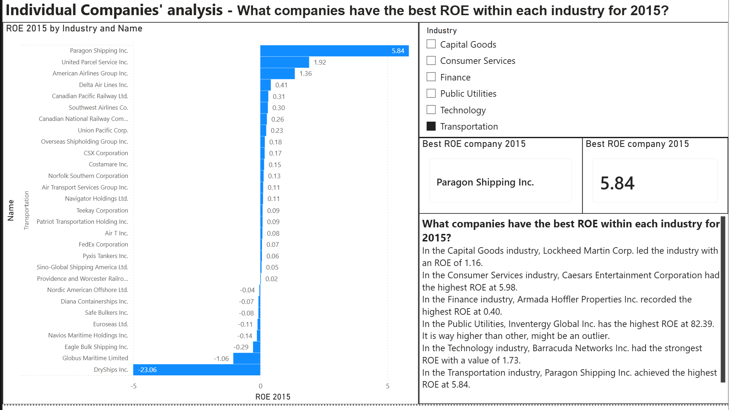
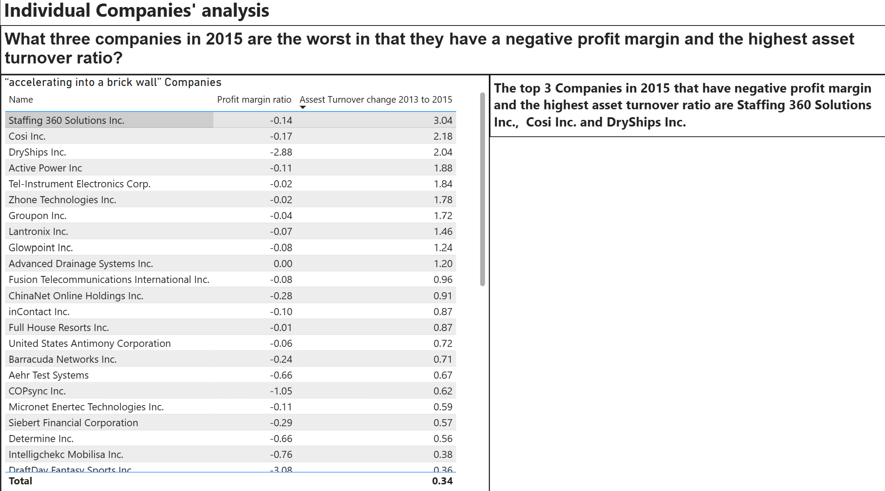
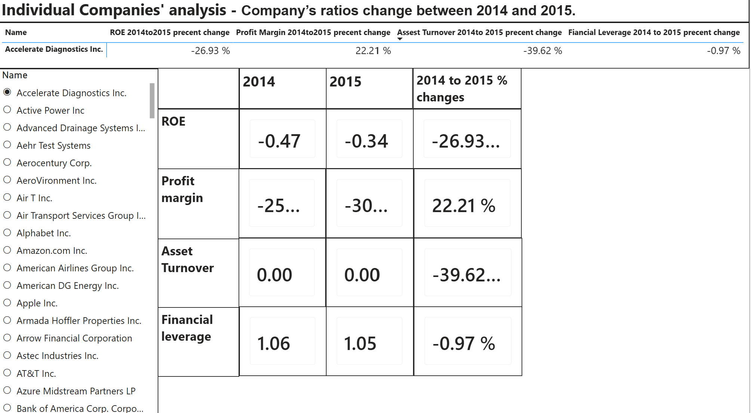
- Companies with the Best ROE in Each Industry (2015)
Industry | Company | ROE
Capital Goods | Lockheed Martin Corp. | 1.16
Consumer Services | Caesars Entertainment Corp. | 5.98
Finance | Armada Hoffler Properties Inc. | 0.40
Public Utilities | Inventergy Global Inc. | 82.39
Technology | Barracuda Networks Inc. | 1.73
Transportation | Paragon Shipping Inc. | 5.84

Inventergy Global Inc. appears to be an extreme outlier with an ROE of 82.39, likely caused by unusually low shareholder equity rather than exceptional operational performance.

- Companies “Accelerating Into a Brick Wall”
These companies had:
- Negative profit margins
- Very high asset turnover ratios
Company | Profit Margin | Asset Turnover
Staffing 360 Solutions Inc. | -0.14 | 3.04
Cosi Inc. | -0.17 | 2.18
DryShips Inc. | -2.88 | 2.04

These firms generated significant sales relative to their assets but still lost money overall, which means that the are improving performance by increasing operational activities. It indicates that their business model remains unprofitable.

- Dashboard Analysis – Company Ratio Changes (2014–2015)
The dashboard allows users to select a company using a slicer and thus check compare ratios across years and analyze percentage changes. Please find detail in tab’Individual company analyse_3’.
The dashboard includes:
- ROE
- Profit Margin
- Asset Turnover
- Financial Leverage
- Percentage change from 2014 to 2015

Conclusion
The DuPont Method provides a powerful framework for understanding company performance by separating profitability, efficiency, and leverage effects.
Key findings from the analysis include:
- Consumer Services achieved the strongest overall ROE performance in 2015.
- Finance showed the greatest improvement in ROE from 2013–2015.
- Finance industries relied heavily on leverage to improve shareholder returns.
- Several companies displayed extremely high ROE values due to outlier effects rather than operational excellence.
- Some firms generated high sales efficiency while remaining unprofitable, demonstrating the importance of analysing multiple ratios together rather than relying on a single performance measure.

